**Project Name: Adding a New Product in the Database.**

**Developer Name:** Kapil Davey

**GitHub Link: https://github.com/kapildavey/Phase-2.git**

**BEFORE ADDING THE DETAILS IN DATABASE:**

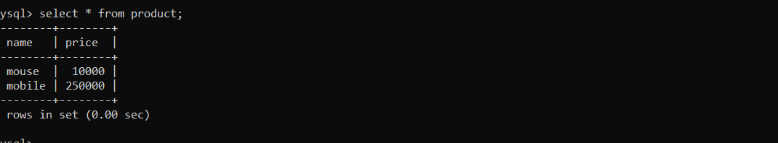

**Add products:**

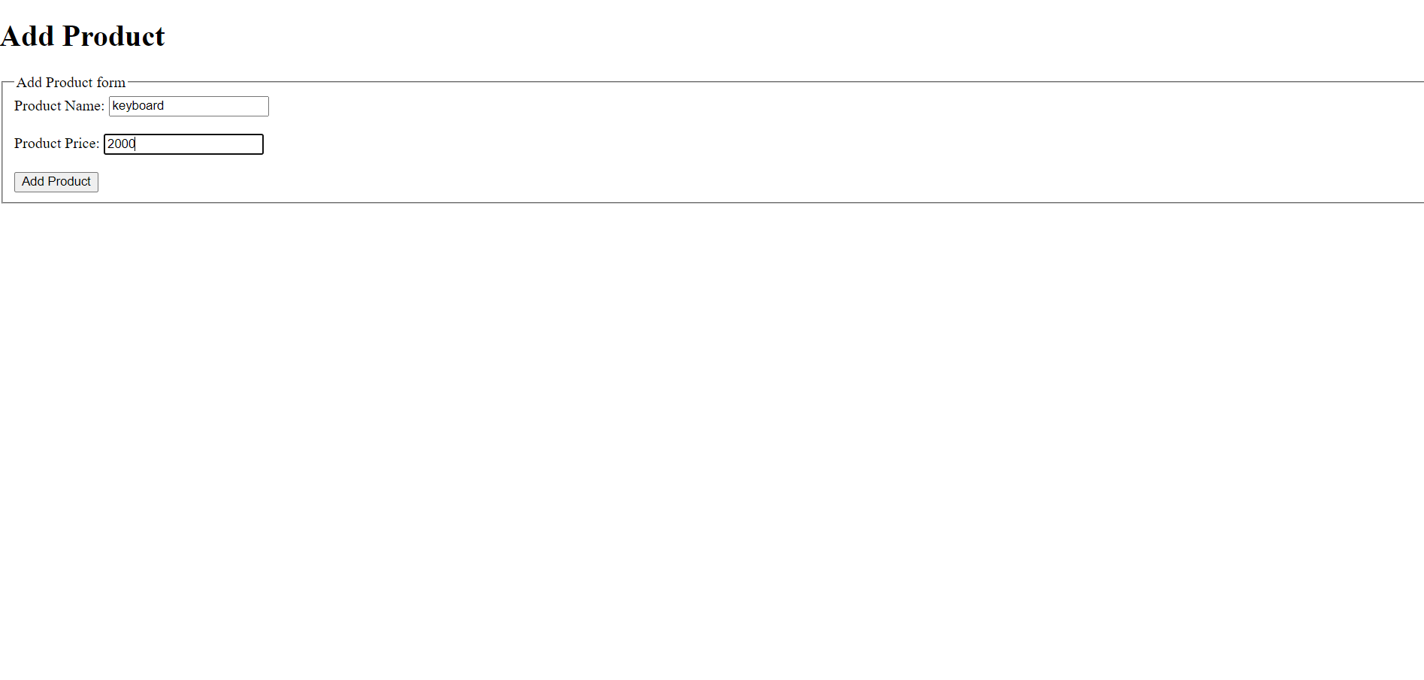

**AFTER ADDING THE DETAILS IN DATABASE:**

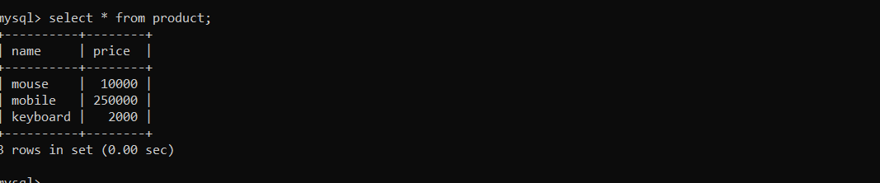

**BASHBOARD FOR ADDING AND READ PRODUCT DETAILS:**

